Greatest Common Divisor

Program running:

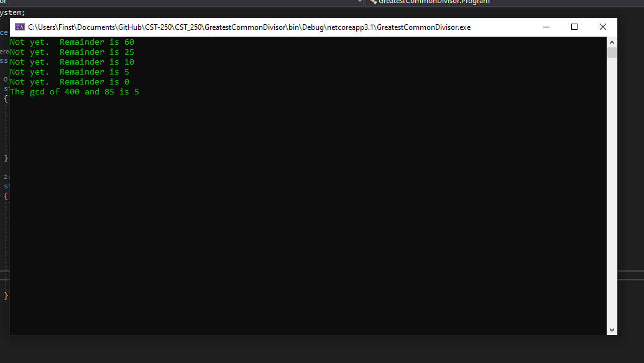

The hard coded values of n1 (400) and n2 (85) are used. Both numbers are passed to the gcd(n1, n2) method. If n2 = 0, n1 is the answer. If not, the method is called again, this time passing n2 as the first number and the remainder of n1 and n2 as the second number. This continues until the remainder is zero.